- “Request an Activity Report” for the project and review to validate that all uploaded HCP data is complete and accurate.

  - Go to “Request an Activity Report” tab on the Extranet.
  - Enter the PO Number for the project
  - An Activity Report that provides the details of all validated upload activity (and documents) for the project will be emailed to the User the within 1 hour.

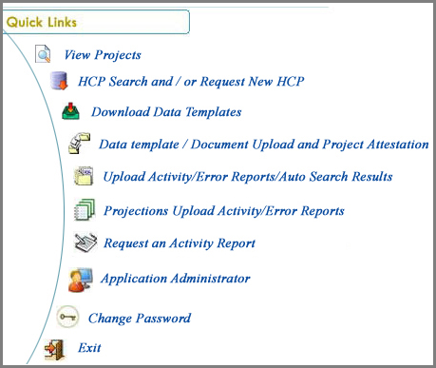

- If errors or duplicate records are identified on the report, complete the attached Data Deletion Request Submission Form (Columns A – L).

- The information needed to complete the form (i.e., File Name, File ID Number and Record Number of each line to be deleted) can be found in the columns at the end of the Activity Report.

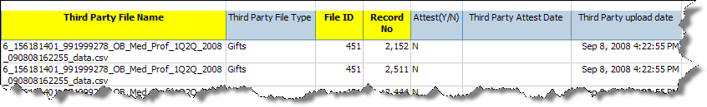
- Contact the helpdesk on the number 1-855-561-4747 with the completed Data deletion form.

- Select the language that you prefer to communicate in.

- The voice prompt will then ask to enter your WWID (World Wide ID)
  - Internal Users enter your WWID.
  - External Users enter “0”

- Then choose option 4 for Business Application Support after listening to voice prompt; this will connect to Helpdesk assistant, who will assist in creating a ticket and also confirm where to submit the data deletion form.

- Once the data deletion process is completed by the helpdesk assistant; the requestor will receive a confirmation email about the completion.

- Upon receipt of the email confirmation, the supplier/requestor must re-run the Activity Report to validate the accuracy of the Final data.

